Increased tick prevalence in eastern/northern Saskatchewan: Observation for LEO
I have worked seasonally (May-July) in Saskatchewan for five years now. I worked there first as a tree planter and then as a planting camp supervisor. Our contracts take us to remote areas around Candle Lake, Shoal Lake, Cumberland House, Carrot River, and Hudson Bay. My first time planting in SK was in the Pasquia Hills in 2020. I was shocked to find four embedded ticks on my body at the end of the first day. As the camp first aider, I had on average 20 people coming to me every night to get ticks removed. I didn’t know this was unusual until 2024 when our forester, a long-time resident of Carrot River, mentioned that even seven years previous, in 2017, she couldn’t remember finding a single tick on her during the summer months.
Figure 1
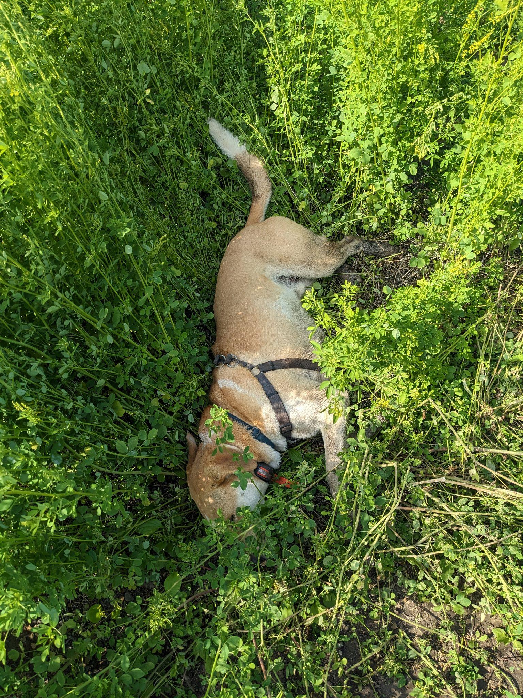
My dog finding a cool place to lay in +30 degrees near Hudson Bay, SK, in May 2023.
Note. On our walk back to the truck that day, my dog’s fur was full of ticks; I found eight American dog ticks crawling on me, and four embedded the following morning.
Although there are over 40 species of ticks in Canada and each has slightly different habitats, tolerances, and cycles, most ticks prefer a moist environment, such as leaf litter, and are particularly active in tall grasses after rain (Tick Talk, n.d.). Ticks may take years to develop from an egg to an adult, and they need blood to be able to go through their life stages; female adults in particular need blood to lay eggs (Government of Canada, 2020). Ticks can survive through the winters under the snow and are active as soon as the temperature rises above 0 degrees Celsius (Tick Talk, n.d.).
A wide breadth of research shows that climate change is a significant, though not the sole, driving factor for this observed tick migration (Bouchard et al., 2019; Elmieh, 2022; Ogden & Lindsay, 2016). Climate change is often used as an umbrella term, so what does this really mean? Bouchard et al. (2019) simplify it this way: with changing weather, we see changes in animal reproduction, animal migration pathways and timelines, human behaviour and migration, and human time spent outdoors. These factors lead to increased number, activity, and habitat range for both ticks and their animal hosts, as well as increased human exposure to ticks (Bouchard et al., 2019). Additionally, research shows that with fluctuations in rain and drought patterns, we are seeing different tick species expand their tolerance for dryness as well as cold temperatures, demonstrating their ability to adapt to changing conditions (Sonenshine, 2018), and providing more explanation for their presence in unusual microenvironments (i.e. the dry prairies). So, how much of this can be traced back to human influence and effects? Estrada-Peña et al. (2012) argue that it is almost impossible to disentangle the web of cause-and-effect in this case, but that human habits definitely play a role, both in influencing climate change as well as spreading population and housing development.
The Climate Atlas of Canada offers a helpful figure to represent changes seen and predicted in regards to warming temperatures and tick prevalence: https://climateatlas.ca/lyme-disease-under-climate-change
Figure 2
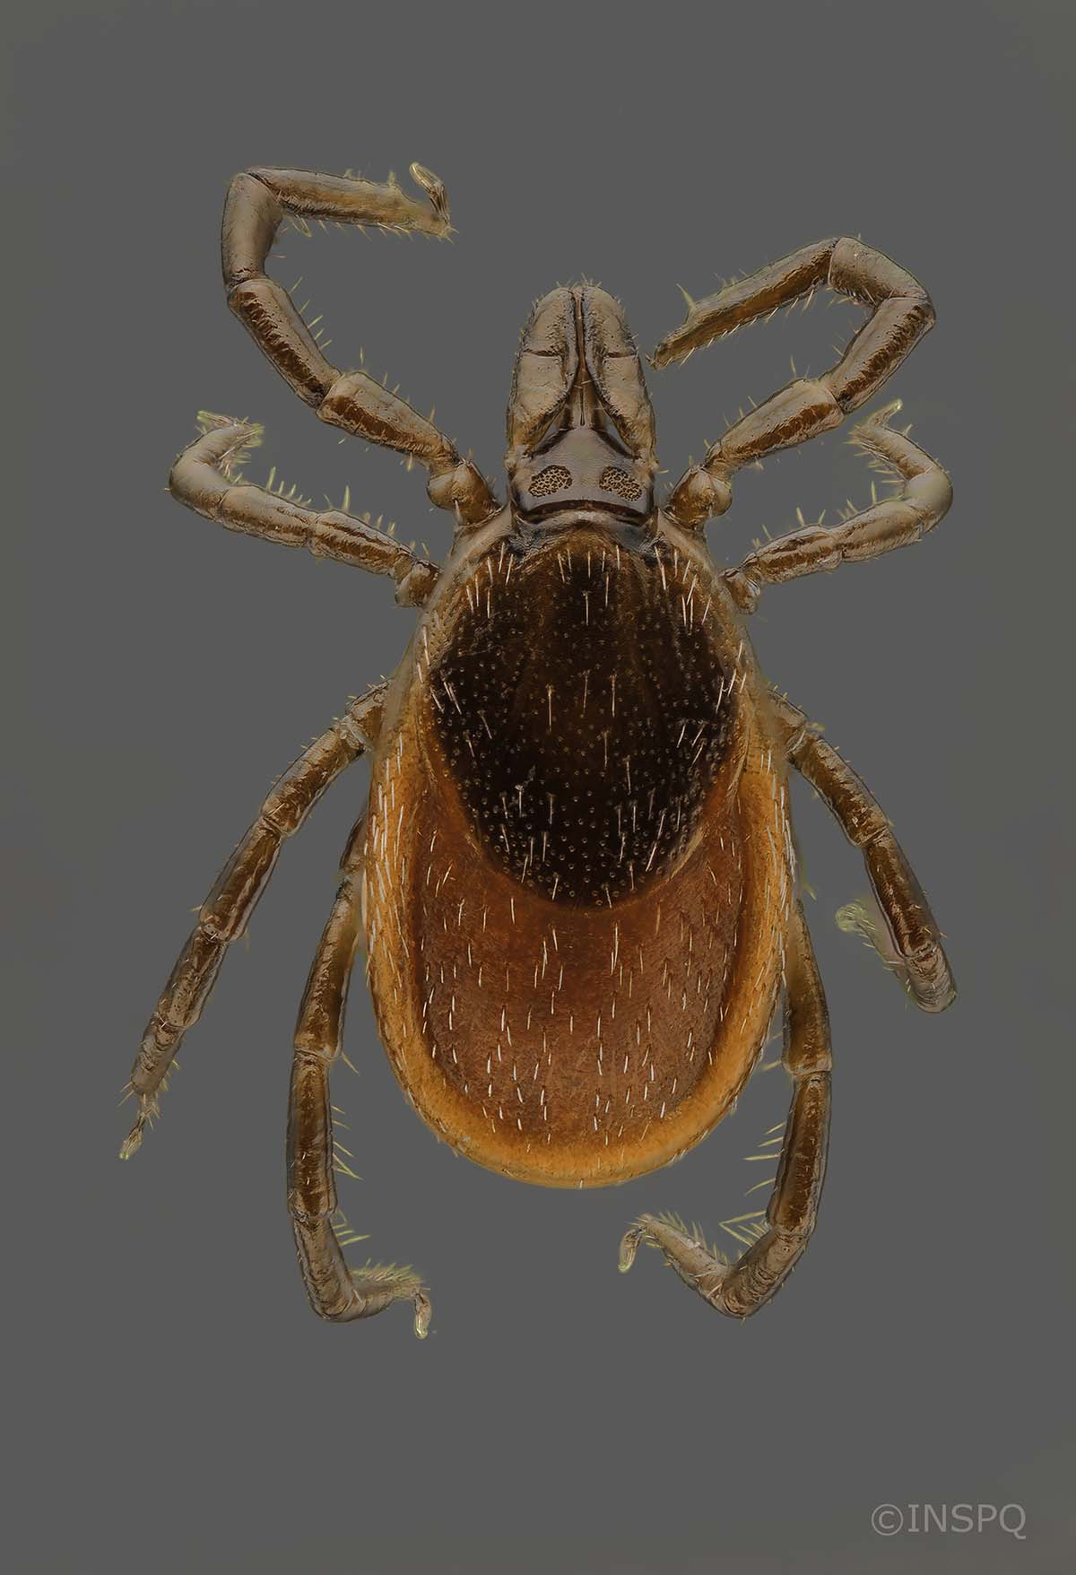
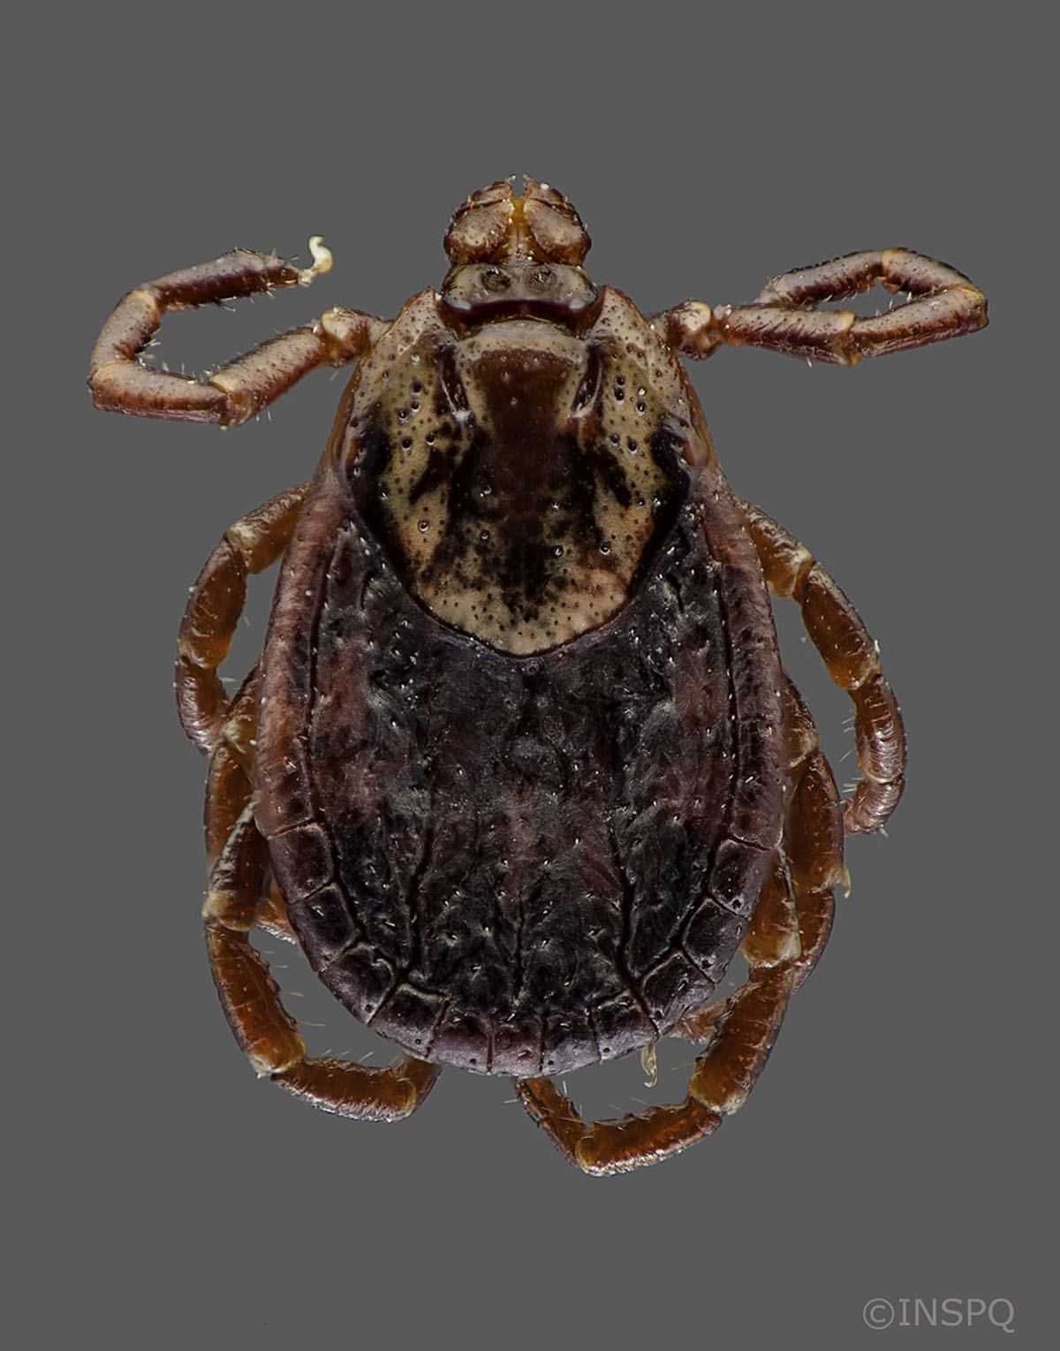
Two (of many) species of ticks, Blacklegged ticks (left) and American dog ticks (right)
Note. From Government of Canada, originally sourced from Institut National de Santé Publique (https://www.canada.ca/en/public-health/services/diseases/ticks-tick-borne-diseases/ticks.html)
Even though Blacklegged ticks are the only species that carry Lyme disease, all species are disease-carriers, posing a great risk to public health (Government of Canada, 2020). I know two people within our company who contracted Lyme disease during planting, creating immense challenges for them daily. This highlights the interconnectedness of all systems, demonstrating how much our lives are affected by natural ecosystem changes, but also how much effect we impose on natural systems (Folke et al., 2002). This also has potential implications for sustainability - with increased tick prevalence, there could be a cascading effect on the economy of pharmaceuticals, weight on medical and veterinary services, research and policy work. In accordance with Holling’s (1986) proposal of a more resilience-based approach to management, Dr. Elmieh suggests there is more work to be done at all government levels to track tick populations so that scientists can more accurately see their habitat progression (Yoon, 2025), and thus society be better equipped to adapt to these changes in creative cross-scalar ways.
While tick tracking is relatively new, a good place to start if you see a tick on yourself or another host is to input your information into eTick - a collaborative data compilation website that has various helpful tips and guides: https://www.etick.ca/en. Dr. Ogden, a senior scientist for Public Health Canada, recommends wearing long pants, tucking them into your socks, and spraying insect repellant over both as easy preventative measures to avoid tick bites (Yoon, 2025). From personal experience, I would also recommend wearing duct-tape (sticky side out) around your ankles with long pants, so that when the tick tries crawling up your leg, it gets stuck on the tape!

Experts to consult: (I will contact these experts separately, as part of the assignment through Royals Roads University)
Dr. Emily Jenkins - Professor and Graduate Chair, Department of Veterinary Microbiology, University of Saskatchewan
Dr. Negar Elmieh - Environmental Health and Knowledge Translation Scientist at the National Collaborating Center for Environmental Health
Dr. Nicholas Ogden - Senior Research Scientist and Director of Public Health Risks Sciences Division in the Public Health Agency of Canada

References
Bouchard, C., Dibernardo, A., Koffi, J., Wood, H., Leighton, P., & Lindsay, L. (2019). Increased risk of tick-borne diseases with climate and environmental changes. Canada Communicable Disease Report, 45(4), 83–89. https://doi.org/10.14745/ccdr.v45i04a02
Elmieh, N. (2022). The impact of climate and land use change on tick-related risks. National Collaborating Centre for Environmental Health. https://ncceh.ca/resources/evidence-reviews/impacts-climate-and-land-use-change-tick-related-risks#h2-7
Estrada-Peña, A., Ayllón, N., & de la Fuente, J. (2012). Impact of climate trends on tick-borne pathogen transmission. Frontiers in Physiology, 3. https://doi.org/10.3389/fphys.2012.00064
Folke, C., S. Carpenter, T. Elmqvist, L. Gunderson, C. S. Holling, B. Walker, J. Bentsson, F. Berkes, J. Colding, K.Danekk, M. Falkenmark, L. Gordon, R. Kasperson, N. Kautsky, A. Kinzig, S. Levin, K. Maler, F. Moberg, L. Ohlsson, P. Olsson, E. Ostrom, W. Reid, J. Rocksrom, H. Svenije & U. Svendin. (2002). Resilience and sustainable development: building adaptive capacity in a world of transformations. Ambio, 31(5), 437-440.
Government of Canada. (2020). Ticks in Canada. Health Canada, Diseases and Conditions. https://www.canada.ca/en/public-health/services/diseases/ticks-tick-borne-diseases/ticks.html
Holling, C. S. (1986). The resilience of terrestrial ecosystems: local surprise and global change. In W. C. Clark & Munn, R. E. (Eds.), Sustainable development of the biosphere. Cambridge UK: Cambridge University Press, 292-317.
Ogden, N. H., & Lindsay, L. R. (2016). Effects of climate and climate change on vectors and vector-borne diseases: Ticks are different. Trends in Parasitology, 32(8), 646–656. https://doi.org/10.1016/j.pt.2016.04.015
Sonenshine, D. (2018). Range expansion of tick disease vectors in North America: Implications for spread of tick-borne disease. International Journal of Environmental Research and Public Health, 15(3), 478. https://doi.org/10.3390/ijerph15030478
Tick Talk. (n.d.). Tick facts. Retrieved October 25, 2025, from https://ticktalkcanada.com/tick-facts/
Yoon, J. (2025, July 30). It’s time to ramp up efforts to prevent tick-borne illnesses, scientists say. CBC News. https://www.cbc.ca/news/health/tick-prevention-canada-1.7596902

