Moose Winter Tick Infestation in Mackenzie, BC – C. Seminoff
Across BC, moose populations in several regions are in decline (Figure 1) (Watt, 2020). The causes of these declines are varied and often poorly understood, though anthropogenic influence is recognized as a contributing factor (Kuzyk et al., 2019). One cause of mortality in moose is winter tick infestations, which can cause hair and blood loss, sometimes resulting in death (Figure 2) (Samuel, 2007; Watt, 2020). According to Watt (2020), the geographic range of winter ticks is expanding north, though there is little baseline data available to confirm this.
Figure 1
Regions Across British Columbia Where Moose Populations are Declining, Increasing, or Stable.
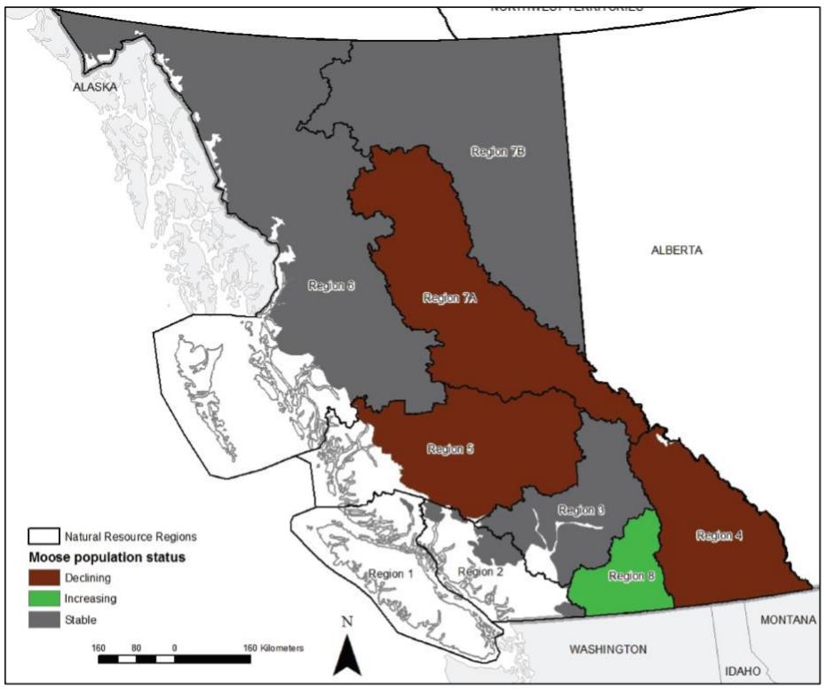
Note. Trends in moose population status by region across BC. Reprinted from Provincial moose winter tick surveillance program by Watt (2020). Copyright 2020 by Ministry of Forests, Lands, Natural Resource Operations and Rural Development.
Figure 2
Different Levels of Hair Loss Representing Winter Tick Infestations in Moose.
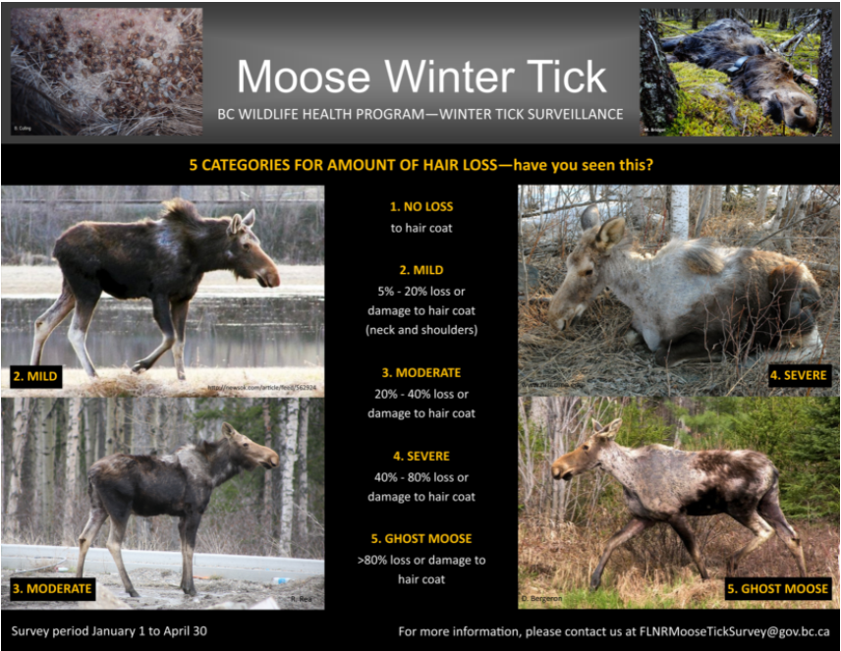
Note. Different levels of hair loss resulting from winter tick infestation. Reprinted from BC wildlife health program moose winter tick survey by Ministry of Forests, Lands, Natural Resource Operations, and Rural Development (FLNRORD) (2021). Copyright 2021 by FLNRORD.
The Provincial Winter Tick Surveillance Program is a government-led citizen science project that uses a reporting site to solicit and gather public information about winter tick infestations across BC (Watt, 2020). The program was initiated in 2015 and runs from January 1st to April 30th annually (Watt, 2020).
The Observation
In 2019, a cow moose near the community of Mackenzie, BC, was struck by a vehicle. Upon closer inspection, this moose was heavily infested with winter ticks. Some locals in the area stated that they had never encountered winter tick infestations in moose in Mackenzie.
Since moving to Mackenzie in April 2016, I have recorded all my observations of moose, with most sightings occurring November through February (Figure 3). Aside from the one occurrence, I haven’t observed any moose with visible signs of winter ticks. According to a local Conservation Officer, his experience with winter tick infestations in Mackenzie is limited to 3 moose (A. Eagles, personal communication, September 25th, 2021). He attended the scene of the struck moose mentioned above and has encountered two other individuals approximately 50km southwest of the community (A. Eagles, personal communication, September 25th, 2021).
Figure 3
Number of Moose Observations by Month from April 2016 to September 2021.

Note. Number of personal moose observations by month from April 2016 to September 2021, showing increased sightings during the annual provincial winter tick surveillance period.
The causal factor of my winter tick observation could be the expansion of winter tick geographic range due to climate change (Sonenshire, 2018). Many different tick species are increasing in abundance and expanding their range due to increasing global temperatures (Sonenshire, 2018). While climate change is recognized as a driver of this expansion, other factors such as habitat modification by humans may have an impact as well (Sonenshire, 2018).
Conclusion
The observation of a moose infested with winter ticks in an area where ticks have historically been absent is concerning at both local and global scales. Locally, the range expansion of ticks could be detrimental to an important food source and to the livelihoods of many residents. This observation is an example of global trends such as biodiversity loss and climate change, which will have social, economic, and environmental impacts.

Comment from Regional Wildlife Biologist
As the author of this observational report has pointed out, moose winter ticks are of concern to wildlife managers across BC, particularly as their distribution expands and their severity increases. The author provides some helpful records and anecdotes of her own moose observations and noted that she has seen minimal evidence of winter tick infestation within the local moose population; however, it appears as though there are some instances occurring in recent years. It will be helpful to monitor such trends in the presence or absence of ticks over time to determine if ticks are expanding into the local moose population, and whether infestations could have population-level implications. It is expected that climate change, particularly mild winters, will benefit the tick’s lifecycle and allow them to expand their distribution and potentially lead to more severe infestations. By maintaining long-term records of moose in the local area, it is likely that trends in tick abundance and distribution could be identified over time. This would be helpful information for local wildlife managers, and ultimately would support moose population management.
Mike Bridger, M.Sc., R.P.Bio. 
Wildlife Biologist | Northeast Region
Ministry of Forests, Lands, Natural Resource Operations and Rural Development
Suite 400, 10003-110th Avenue, Fort St. John, BC, V1J 6M7
Ph: 778-576-8933

References
Farley, J., & Voinov, A. (2016). Economics, socio-ecological resilience and ecosystem services. Journal of Environmental Management, 183, 389–398. https://doi.org/10.1016/j.jenvman.2016.07.065
Holling, C. S. (1986). The resilience of terrestrial ecosystems: local surprise and global change. In W. C. Clark & R. E. Mann (Eds.), Sustainable Development of the Biosphere. Cambridge University Press. https://moodle.royalroads.ca/moodle/pluginfile.php/865463/mod_page/content/18/The resilience of terrestrial ecosystems %28Sustainable development of the biosphere pp.292-317%29.pdf
Kuzyk, G., Procter, C., Marshall, S., & Hodder, D. (2019). Factors affecting moose population declines in British Columbia: Updated research design. Ministry of Forests, Lands, Natural Resource Operations and Rural Development. https://www2.gov.bc.ca/assets/gov/environment/plants-animals-and-ecosystems/wildlife-wildlife-habitat/moose/factors_affecting_moose_population_declines_in_british_columbia_updated_research_design_-_2019.pdf?bcgovtm=20200319_GCPE_AM_COVID_.
Ministry of Forests, Lands, and Natural Resource Operations (FLNRO). (2015). Provincial framework for moose management in British Columbia. Forests, Lands, and Natural Resource Operations. http://www.env.gov.bc.ca/fw/wildlife/management-issues/docs/provincial_framework_for_moose_management_bc.pdf.
Ministry of Forests, Lands, Natural Resource Operations and Rural Development (FLNRORD). (2021). BC wildlife health program moose winter tick survey. https://www2.gov.bc.ca/gov/content/environment/plants-animals-ecosystems/wildlife/wildlife-health/wildlife-health-matters/moose-health/moose-winter-tick-survey
Samuel, W. M. (2007). Factors affecting epizootics of winter ticks and mortality of moose. Alces, 43, 39–48. Retrieved September 25, 2021, from https://web.a.ebscohost.com/ehost/pdfviewer/pdfviewer?vid=1&sid=26734b13-c507-4666-a171-26f3818acd69%40sdc-v-sessmgr01.
Sonenshire, D. E. (2018). Range expansion of tick disease vectors in North America: Implications for spread of tick-borne disease. International Journal of Environmental Research and Public Health, 15(3), 1–9. https://dx.doi.org/10.3390%2Fijerph15030478
UN Environment Programme (UNEP). (2019). Global Environment Outlook 6. https://www.unep.org/resources/global-environment-outlook-6.
Watt, K. (2020). Provincial moose winter tick surveillance program. Ministry of Forests, Lands, Natural Resource Operations, and Rural Development. https://www2.gov.bc.ca/assets/gov/environment/plants-animals-and-ecosystems/wildlife-wildlife-habitat/wildlife-health/wildlife-health-documents/provincial_moose_winter_tick_program_report.pdf.

