Assignment #1 – The Return of Wildlife to Urban Areas
EECO 586 The Biosphere and Sustainability
Author: Elizabeth Scharfenberger
Prepared for David Oswald

Observation
Around the globe, wildlife sightings have become more prominent in urban areas (Singh, 2020). In Edmonton, Alberta, animals like the downy woodpecker and grouse, which haven’t been seen in 20 years, are visiting the city (Figures 1 and 2).
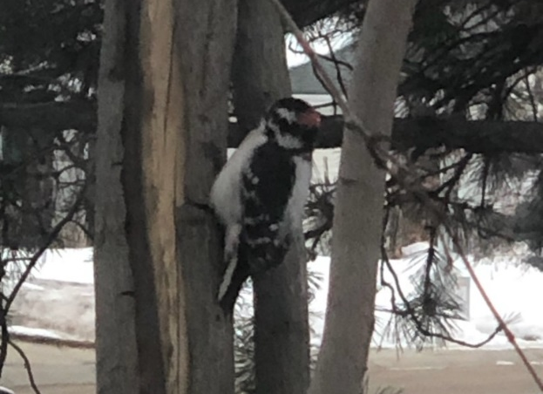
Figure 1 Downy Woodpecker
Figure 2 Grouse
Interpretation
On January 30, 2020, the World Health Organization (WHO) declared the outbreak of COVID-19 a Public Health Emergency of International Concern (WHO, 2020). Since the discovery of the novel coronavirus on December 31, 2019 (WHO, 2020), humans across the globe have had to drastically change their daily habits. Everyone is experiencing a new type of normal of social distancing, where leaving the house is only for essential items like groceries and visiting with friends and family has shifted to virtual contact. Since social distancing measures where implemented, human activity has decreased significantly. With people no longer milling about in the streets, driving to and from places regularly, and remaining at home or close to home, wildlife has started to venture into urban areas no longer teeming with humans (TheStar, 2020; Roger, 2020).
Humans cause stress on wildlife (Fowler, 1999; Higham & Shelton, 2011; Martin & Réale, 2008; Soulsbury & White, 2016). Soulsbury & White note that human induced ecosystem pressures such as pollution, habitat fragmentation, and other disturbances make “urban areas challenging environments for wildlife to survive in” (2016, p. 2). Thus, by reducing or removing human presence and disturbance, wildlife stress levels are reduced allowing them to venture into territory that originally caused them stress due the removal of the perceived threat. The return of wildlife to cities shows that nature will take back that space humans have disturbed and turn it back into a natural wild place.
Potential Consults
Preferred consults: Carl Soulsbury and Piran White are co authors of a study on the interactions between humans and wildlife in urban areas (2016). Soulsbury and White are authors of 84 and 293 research articles, respectively. Soulsbury specializes in behavioural ecology and evolutionary biology and is a Senior Lecturer in the School of Life Sciences at the University of Lincoln (U of L) in the United Kingdom (UK) (U of L, 2019). White is a professor at the University of York, UK, who researches human-environment interactions.
Other potential consults: Dr. Chirsto Fabricius is a Global Wildlife Lead Scientist at the World Wildlife Fund (WWF). One of the WWF’s goals focuses on wildlife conservation by empowering local communities to protect wildlife (WWF, 2020). Nissa Petterson is a conservation specialist with the Alberta Wilderness Association (AWA). She monitors province-wide issues involving wildlife and public lands management. The AWA is a non-government organization (NGO) conservation group that advocates for Alberta’s wildlands, wildwater, and wildlife (AWA, 2020).
Conclusion
The return of wildlife brings nature closer to home, which can benefit society through improved mental health and wellbeing; provision, regulation, and support of ecosystem services through biodiversity; and enhanced cultural and recreational value through aesthetics and enjoyment of green spaces and wildlife (Soulsbury & White, 2016). Hopefully, by seeing wildlife regularly and allowing co-existence, a shift can occur away from the paradigm that humans are separate from nature towards a new paradigm that humans are part of nature. By noticing and enjoying the presence local wildlife, people can enhance their sense of place by understanding what the space they live is can offer (Dale, Ling & Newman, 2008; Thomashow, 2003).

Resources
Alberta Wilderness Association (AWA). (2020). About Us. Retrieved from: https://albertawilderness.ca/about-us/
Dale, A., C. Ling & L. Newman (2008). Does place matter? Sustainable community development in three Canadian communities. Ethics, Place and Environment: A Journal of Philosophy and Geography, 11(3), 267-281
Folke, C., A. Jansson, J. Rockstrom et al (2011). Reconnecting to the Biosphere. AMBIO, 40(7), 719-738.
Fowler, G. S. (1999). Behavioral and hormonal responses of Magellanic penguins (Spheniscus magellanicus) to tourism and nest site visitation. Biological Conservation, 90(2), 143-149.
Higham, J. E. S., & Shelton, E. J. (2011). Tourism and wildlife habituation: reduced population fitness or cessation of impact? Tourism Management, 32(6), 1290-1298.
Martin, J. G., & Réale, D. (2008). Animal temperament and human disturbance: implications for the response of wildlife to tourism. Behavioural Processes, 77(1), 66-72.
Roger, T.N. (2020). LA’s skies are smog-free and peacocks are roaming the streets of Dubai. Photos show how nature has returned to cities shut down by the coronavirus pandemic. Retrieved from Business Insider: https://www.businessinsider.com/photos-show-nature-is-reclaiming-urban-areas-amid-coronavirus-2020-4
Singh, M. (2020). Emboldened wild animals venture into locked-down cities worldwide. Retrieved from the Guardian: https://www.theguardian.com/world/2020/mar/22/animals-cities-coronavirus-lockdowns-deer-raccoons
Soulsbury, C. D., & White, P. C. (2016). Human–wildlife interactions in urban areas: a review of conflicts, benefits and opportunities. Wildlife research, 42(7), 541-553.
TheStar. (2020). COVID-19: Wildlife pics go viral on social media as nature takes back world’s empty city streets. Retrieved from: https://www.thestar.com.my/tech/tech-news/2020/03/30/covid-19-wildlife-pics-go-viral-on-social-media-as-nature-takes-back-worlds-empty-city-streets
Thomashow, M. (2003). Chapter 4: A Place-Based Perceptual Ecology. In Bringing the Biosphere Home: Learning to Perceive Global Environmental Change (pp. 73-104). Cambridge MA, MIT Press.
University of Lincoln (U of L). (2019). Staff directory: Carl Soulsbury. Retrieved from: https://staff.lincoln.ac.uk/csoulsbury
World Health Organization (WHO). (2020). Rolling updates on coronavirus disease (COVID-19). Retrieved from: https://www.who.int/emergencies/diseases/novel-coronavirus-2019/events-as-they-happen
World Wildlife Fund (WWF). (2020). About Us. Retrieved from: https://www.worldwildlife.org/about

